**CS 5551 - Advanced Software Engineering**

**Project Final Report**

**Spring 2017**



TEAM NAME: TECHIE

TEAM NUMBER:21

BHAVESH VEERAMACHANENI

TEJASWINI PULIVARTHI

BRAHMANI KANIKANTI

LAKSHMI MONICA NADAKUDITI

# Table of Contents

1. Introduction 3
2. Project Deployment & Project Management 3
   1. Welcome Page 3
   2. Login Page 4
   3. Registration Page 4
   4. Dashboard and diets Page 5
   5. Food Page 5
   6. Recipe Search Page 7
   7. Exercise Page 7
   8. Gym Finder Page 8
   9. Reports Page 9
3. Project Proposal 9
4. Project Plan 11
   1. Class Diagram 11
   2. Sequence Diagram 12
   3. Architecture Diagram 13 5. First increment Report 13

6. Second Increment Report 13 7. Third Increment Report 14 8. Fourth Increment Report 14

1. Test Cases 15
2. Project management 15
3. Presentation Slides URL. 16
4. Github URL. 16
5. Youtube URL. 16
6. Future Work 16

15. Bibliography 16

# 1.Introduction

**FITNESS DIARY:**

we believe that best way to lose weight is simply to keep track of foods we take in. Without a proper diet and tracking we think we waste a lot of time and energy simply having unhealthy food and later stressing to reduce the consequences of it. So we would like to design an app that make calorie counting and food tracking easy so we could track the health and weight anywhere anytime. This would give you a brief description of what to and what not to until you attain your goal.

1. **Project Deployment & Project Management**

**Application:**

* 1. Welcome page for the application



* 1. Login page for the application



* 1. Registration page for the application

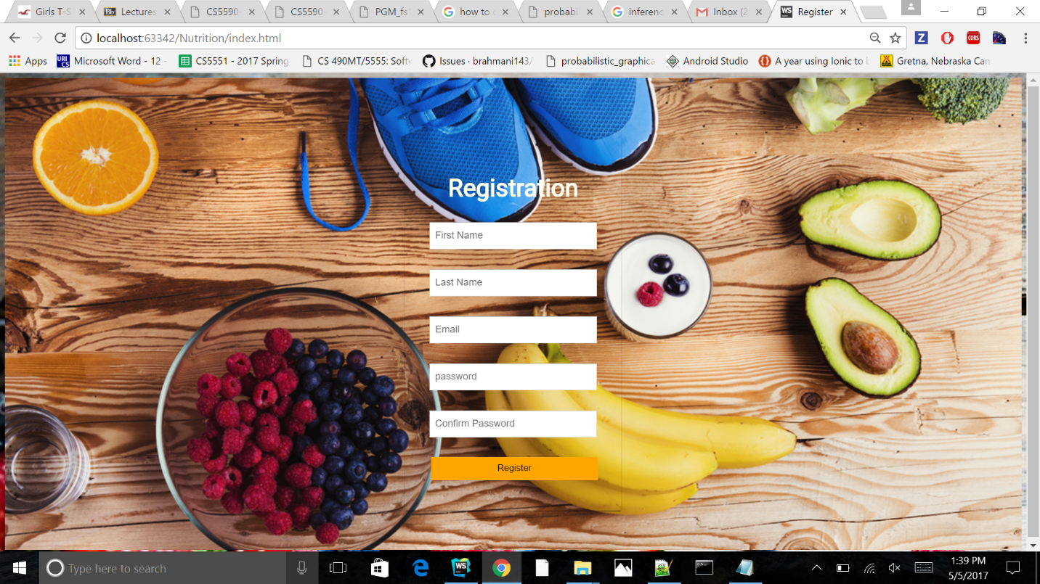

* 1. Dashboard and diets page for the application

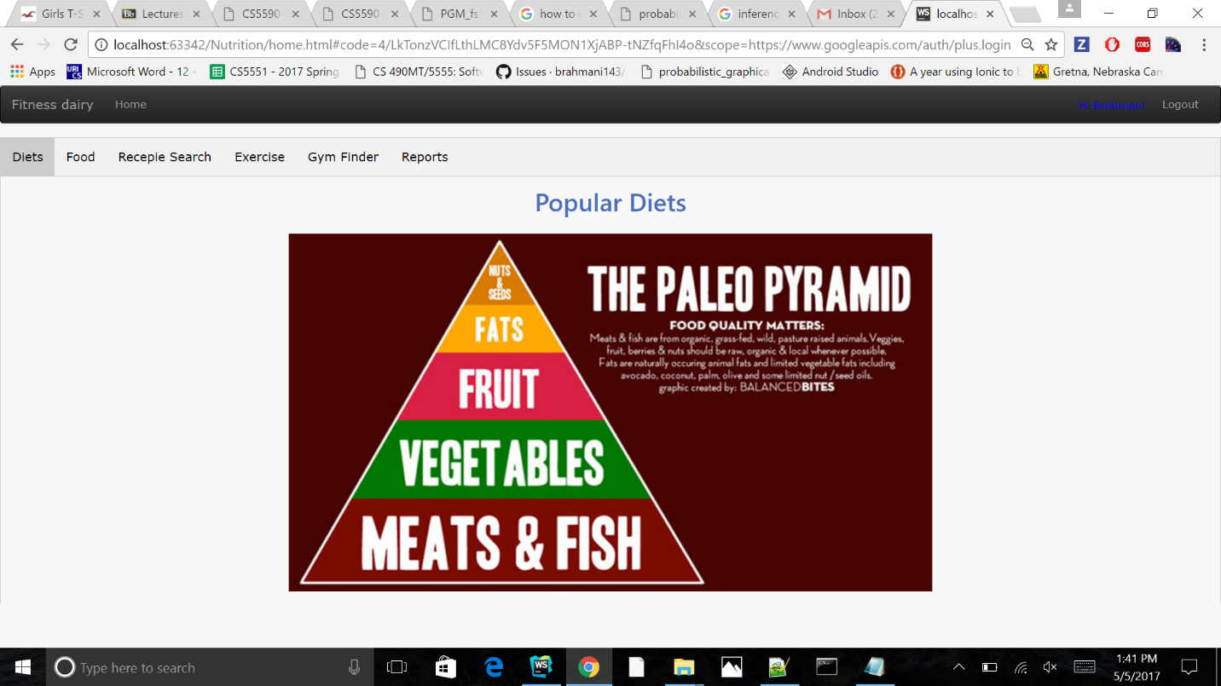

* 1. Food page for the application

Here we calculate and store calories of the food we eat.

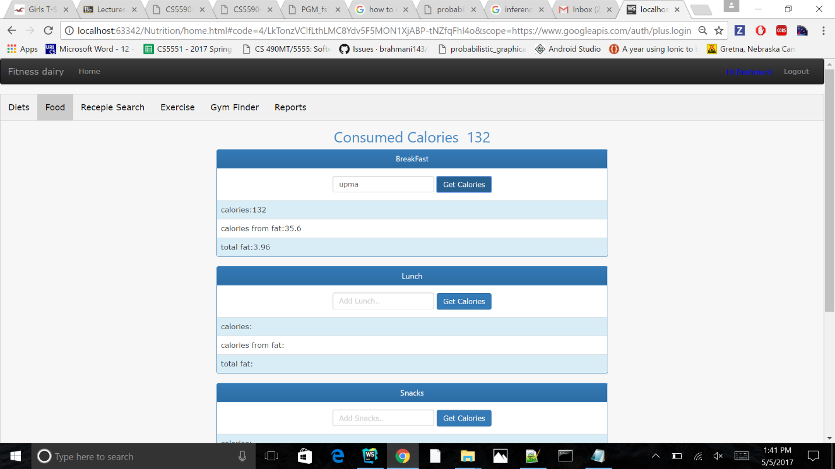

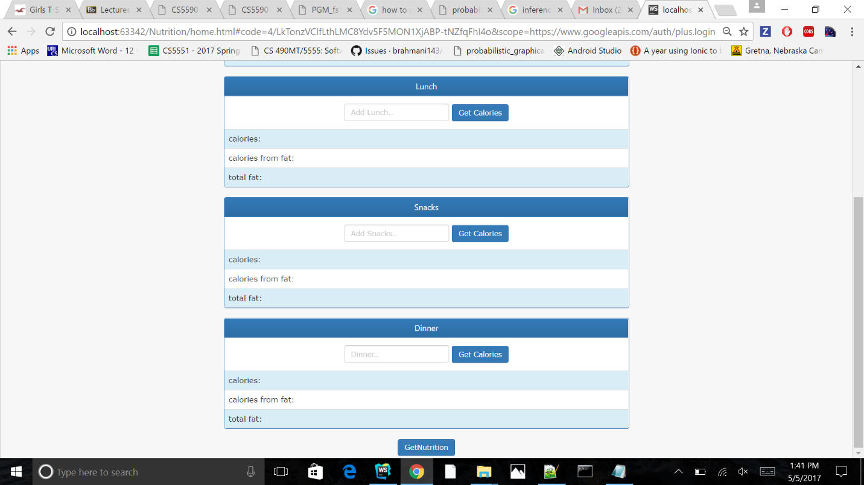

We can also get the nutrition chart.

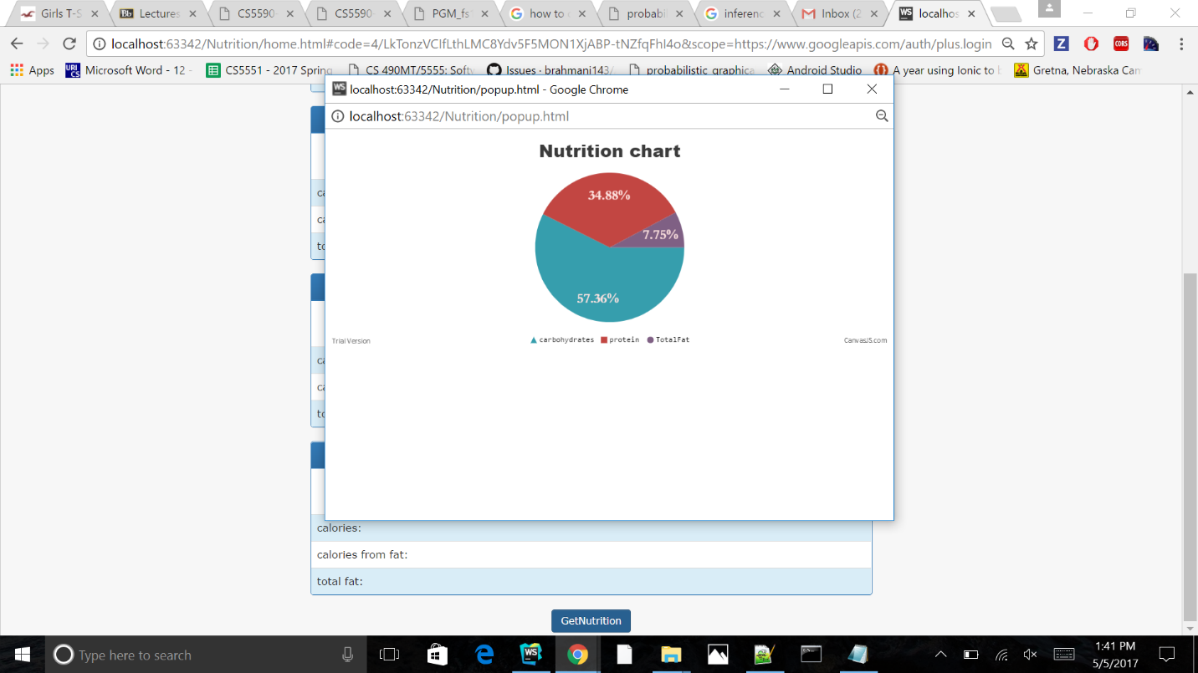

* 1. Recipe Search page for the application

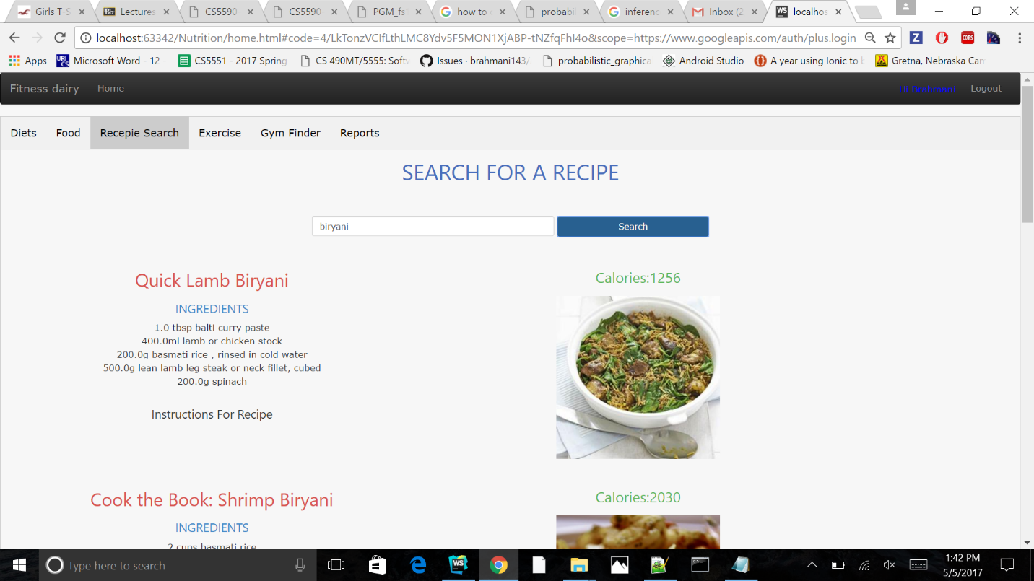

* 1. Exercise Page for the application

Here we calculate intake calories and store them in database.

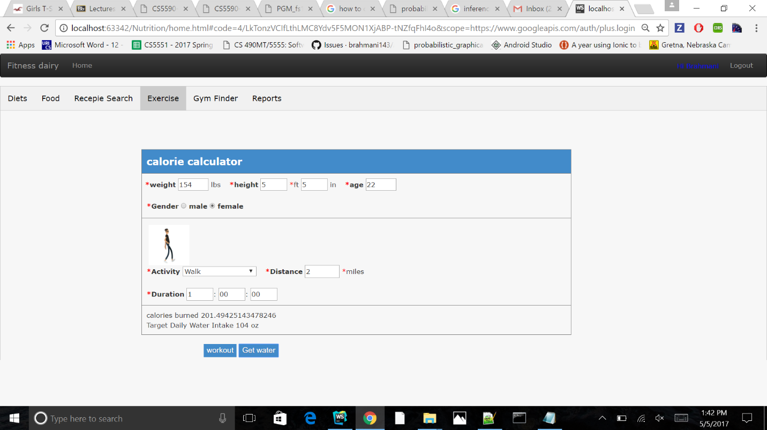

* 1. Gym Finder page for the application

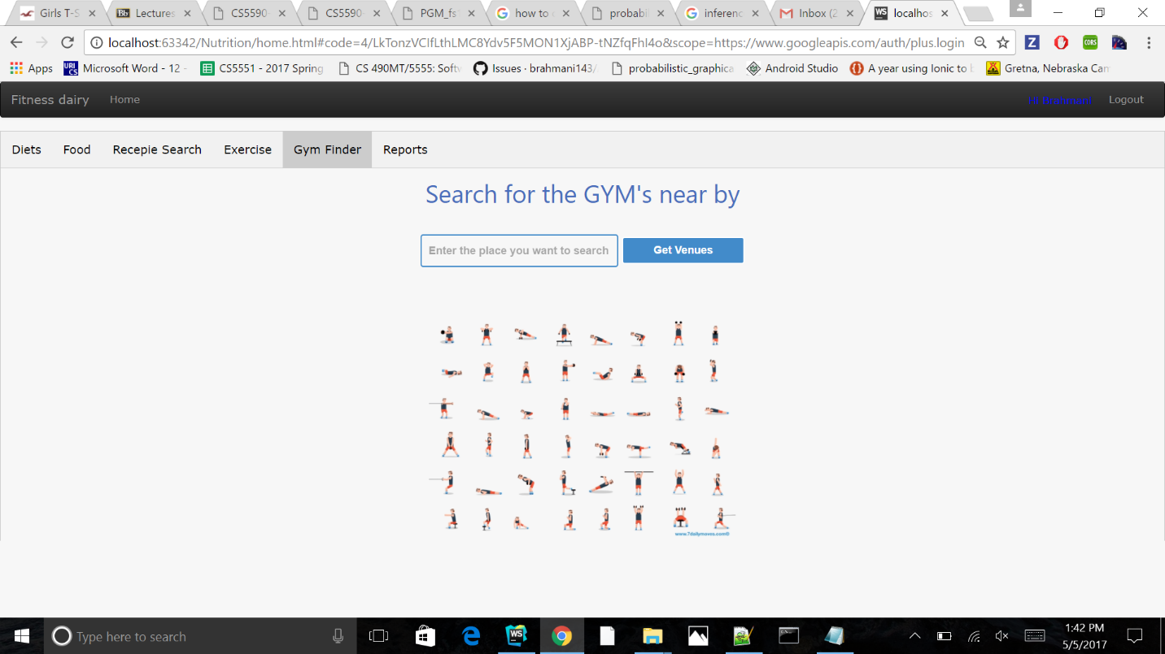

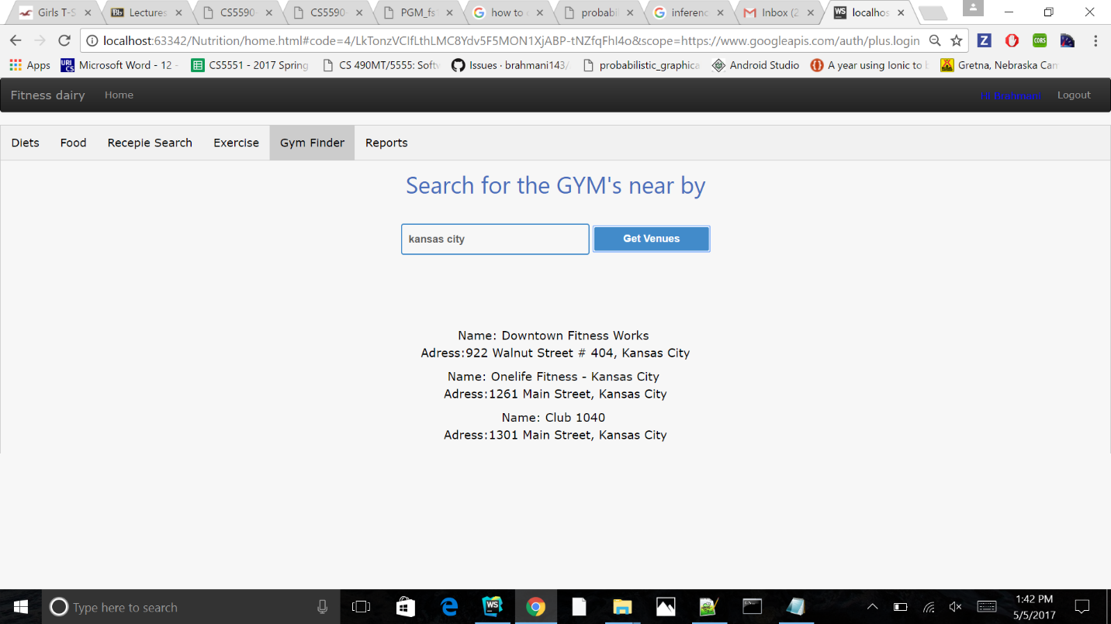

* 1. Reports page for the application

Here we show weekly summary on line basis graph.

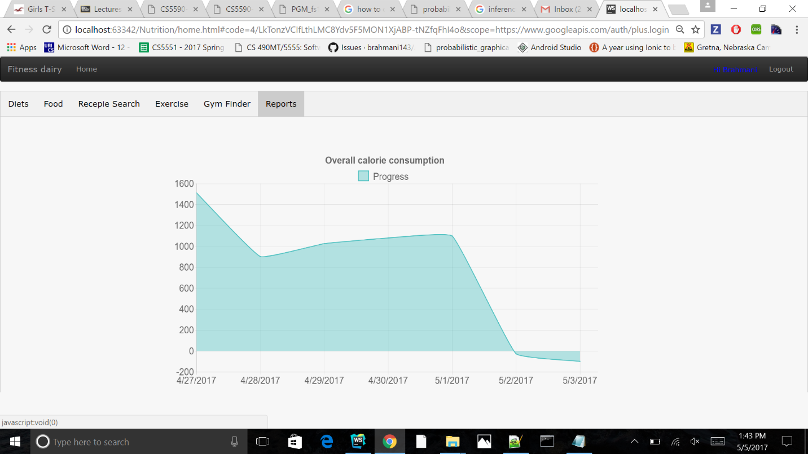

1. **Project Proposal Project Goal:**

**UNIQUENESS:**

We focus on making sure that users can log their meals as quickly and as easily as possible. Our idea is, the easier we make it for users the more likely they are to stay on track and the more likely they are to succeed in their weight loss goals.

We will create a place where the user either want to increase the weight or to decrease the weight. We want to show them how many calories have been taken and show suggestions accordingly so that they can either increase or decrease the weight. We create a home page where users must set their goal and what they have taken in. The app searches for the calorie count automatically and we also provide a custom calorie count option where the user enters the calorie of unknown food. We also provide a feature where it takes input as ingredients and gives output as what food is best keeping goal in mind. It will automatically generate a book or diary of your daily events so that you can track your changes.

**OBJECTIVES:**

Loose or gain the weight in a healthy manner by keeping track of food we eat and activities we do and finding nutritional values for the food we take. Getting low calorie or high protein or high nutritional recipes with the ingredients left in our home.

**SYSTEM FEATURE**S:

* Food Search
* Calorie counter
* Recipes for Left off ingredients
* Nutrition Pie chart
* Exercise search
* Goals and their progress

1. **Project Plan**

* 1. **Class Diagram**

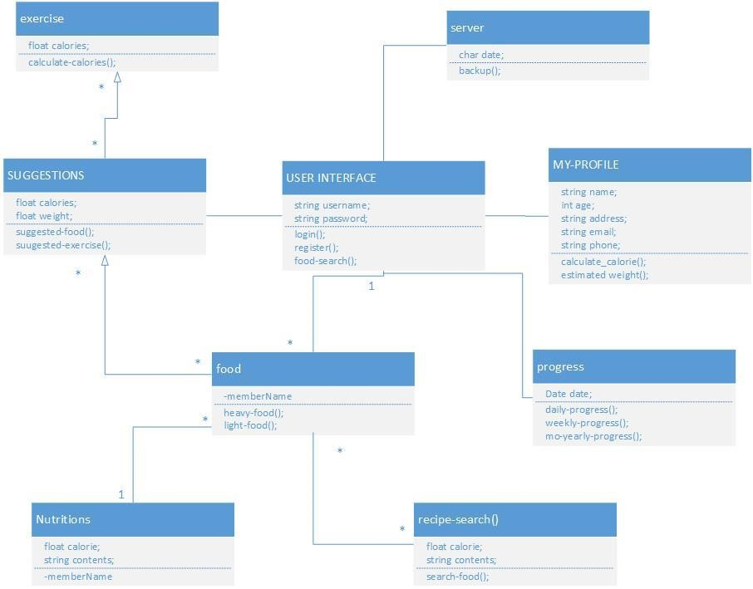

* 1. **Sequence Diagram**

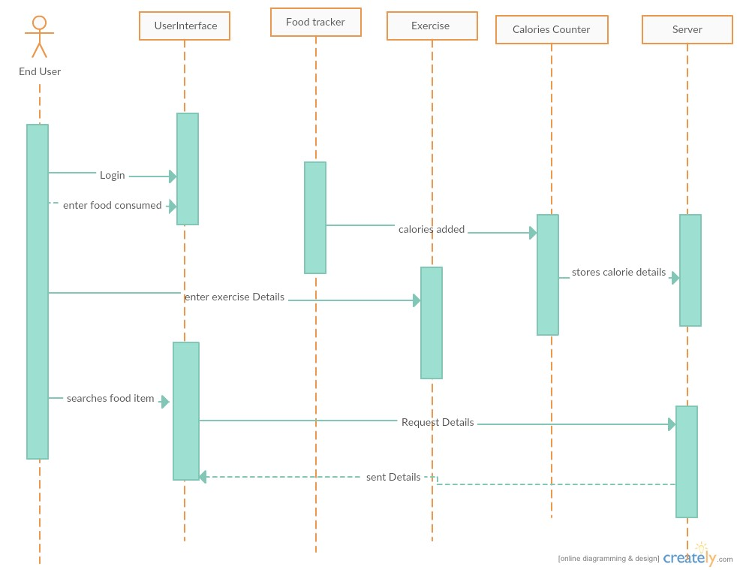

* 1. **Architecture Diagram**

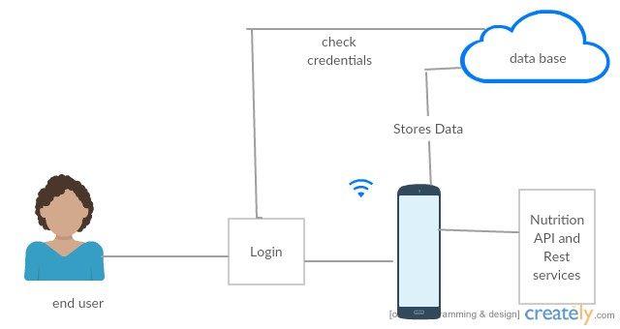

1. **First increment Report**

**Implementation:**

In the first increment we have implemented the following features.

* + - * We had developed the login and registration page.
      * If he/she is a new user, he/she have to sign up by entering the details.
      * Once the user is registered, he can use the login page to access the application.
      * We have used webstorm for this implementation.

1. **Second Increment Report**

**Implementation:**

In the second increment, we had implemented the following features.

* We have implemented exercise page, food page, recipe search and gym finder pages.
* We also improved the UI of home page.

1. **Third Increment Report**

**Implementation:**

In the third increment, we had implemented the following features.

* Here we have selected MongoDB as our database.
* We have stored login details and validated them for user login.
* Here we started to store user daily basis details in MongoDB but was not completed because we first thought to store data as collection in a collection but as it was not successful we have gone through multiple collections and this is done in 4th increment.

1. **Fourth Increment Report**

**Implementation:**

In the fourth increment, we had implemented the following features.

* Here we finished to store and retrieve user daily details.
* Using this data we created line graph in reports page.
* We also provided google OAuth and facebook OAuth to login.
* We also included a new diet page which includes popular diets.
* We have improved UI by adding some gif’s.

1. **Test cases:**

|  |  |  |  |
| --- | --- | --- | --- |
| **Case** | **Test case Description** | **Expected Result** | **Actual Result** |
| Login | Enter invalid username and password | Error message should pop up saying invalid credentials. | PASS |
| Login | Enter invalid username and valid password | Error message should pop up saying invalid credentials. | PASS |
| Login | Enter valid username and invalid password | Error message should pop up saying invalid credentials. | PASS |
| Login | Enter valid username and password | Page should redirect to Home page | PASS |
| Signup | Email id format should end with @mail.com | Give error message incorrect email id format | PASS |
| Signup | Password of length 8 characters | Gives error message password is weak | PASS |
| Signup | Password and confirm password should match | If this succeeds it redirects to login page | PASS |

1. **Project Management:**

Implementation status report:

**Technologies Used:** WebStorm, MongoDB, JavaScript, AngularJS, HTML5, CSS, BootStrap, chart.js

**Work Completed**

* + - * Design and Architecture of the Application.
      * Login and Registration using MongoDB.
      * Implemented Dashboard and diet Page.
      * Implemented Home Page.
      * Implemented food Page.
      * Implemented exercise Page.
      * Implemented Recipe search page.
      * Implemented Gym Finder page.
      * Implemented Reports Page.

1. **Presentation Slides URL**

https://drive.google.com/file/d/0B6LYpoTklJiSOUF6cGlSTmlYd2M/view

1. **GITHUB URL**

<https://github.com/Tejaswini94/ASE_PROJECT>

1. **YOUTUBE URL**

<https://www.youtube.com/watch?v=iZqg2AZ-PdU>

1. **FUTURE WORK**

* We want to add animations to the UI.
* We want to add maps near gym finder.
* We want to add more options in workouts.
* We want to provide more graphs and tabular basis reports.

1. **BIBILOGRAPHY**

* <http://stackoverflow.com/>
* <http://developers.facebook.com>
* <http://developers.google.com>
* <http://mapmyfitness.com>
* <http://underarmour.com>